Appendix 4: Attendance Policy Quick Guide for Parents

Attendance Policy Quick Guide for Parents
We expect pupils to attend school for 100% of the academic year.

You can support your child to have excellent attendance by taking these steps:
- Ensure your child arrives on time for school every day and is ready to learn. Arriving after registration is recorded as an unauthorised absence. Pupils must be in school by 08:25.
- If your child appears to be only slightly ill, send them in to school. We have staff who will contact you if their condition deteriorates.
- Book any medical appointments outside of school hours. If this is unavoidable, please book for as late in the afternoon as possible and inform the school of appointments in advance.
- Supply a copy of the appointment card or hospital letter if your child has an appointment during school hours.
If your child becomes reluctant to go to school or you need help, please contact the school immediately; we are more likely to be able to work together to solve any problems if we act early.

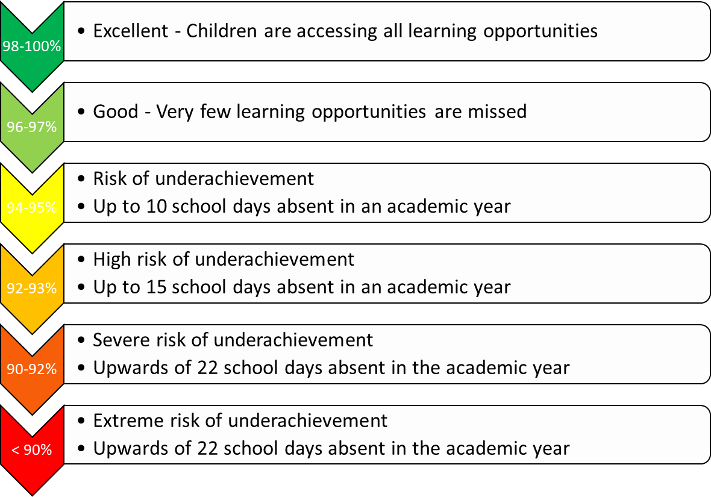

‘On the day’ absences: what should I do if my child is not ‘fit’ to go into school?
On each day your child is unfit to come to school, please report this absence using the report an absence tab on ClassCharts before 8am to let us know and give the specific reason for absence. The information you give will be recorded on our official register.

Leave of Absence
There may be exceptional circumstances where you need to request a leave of absence for your child. Please use our ‘Leave of absence request’ form to make these types of requests. The form should be submitted in advance of the leave of absence, via Swanmore College. You will receive a letter in response, to advise if the request has been granted or declined.

Punctuality
Pupils are expected to arrive on time for school in the morning and for every lesson during the day. Your child is late to school if they are not in Tutor by 08:25.
The Government remains very clear that no child should miss school apart from in exceptional circumstances and schools must continue to take steps to reduce absence to support children’s attainment. I hope we can count on your support in this matter.
Please contact your child’s Form Tutor if you require any support with ensuring your child’s regular school attendance.

