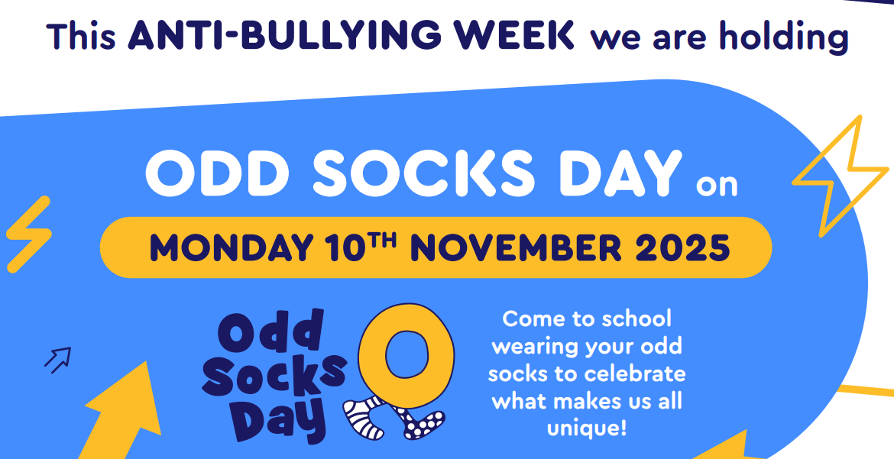
Anti-Bullying Ambassadors
Your Tutor
Any Adult
Email: antibullying@swanmore-sec.hants.sch.uk



